Setup Ubuntu Main Server

<F2>

-INSERT USB Disk

“System BIOS”

“Boot Settings”

* Boot Mode BIOS

“BIOS Boot Settings”

* Boot Option Enable/Disable

✓ Hard Drive C:

Hard-Disk Drive Sequence

* select USB disk, ++++ until on top
* <TAB> to “OK” <ENTER>

<ESC><ESC><ESC>

<TAB> to “FINISH” <ENTER>

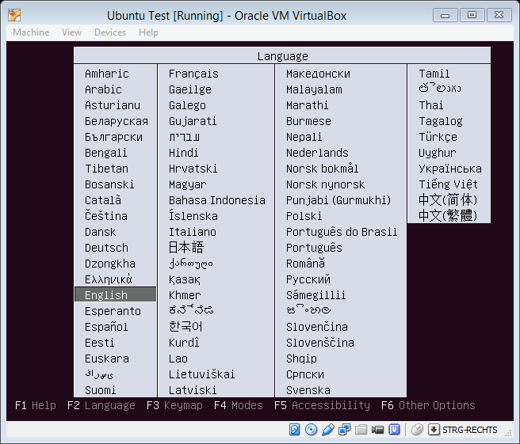

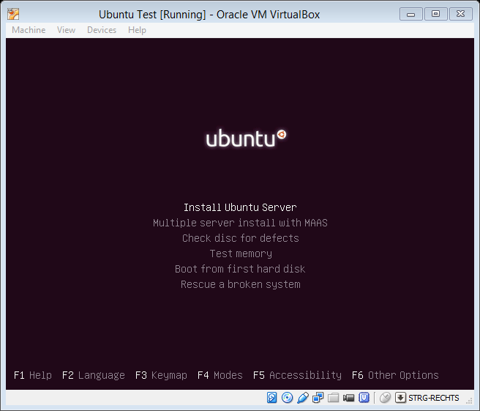

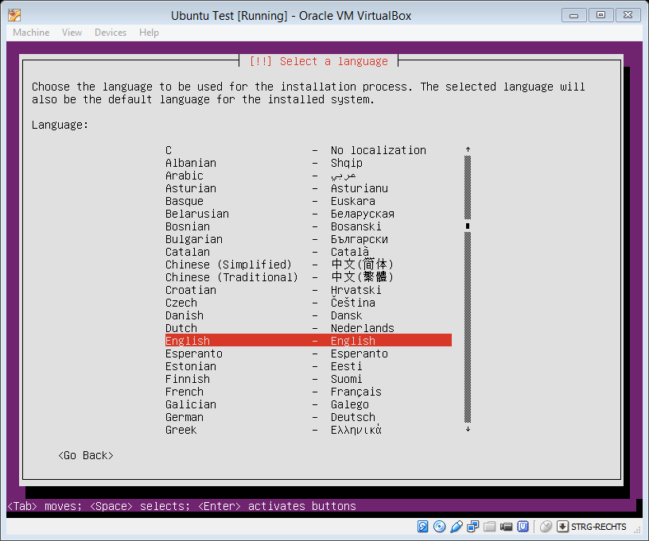

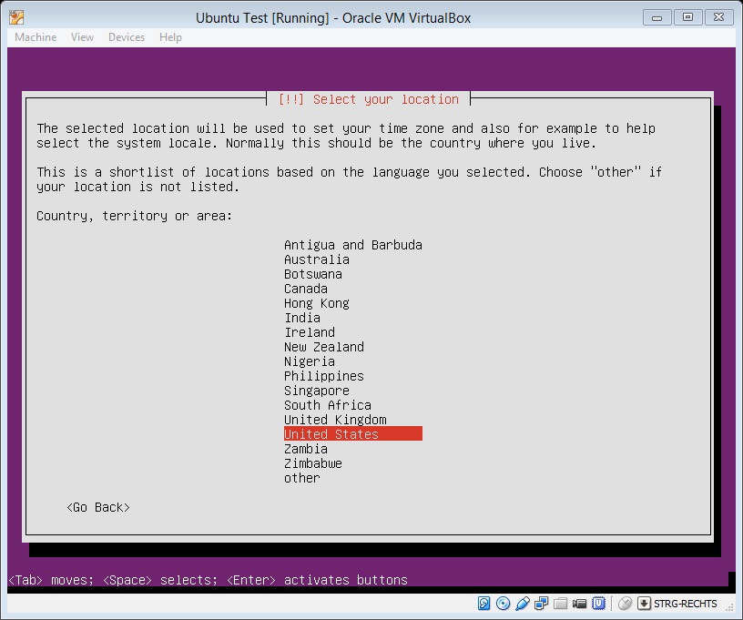

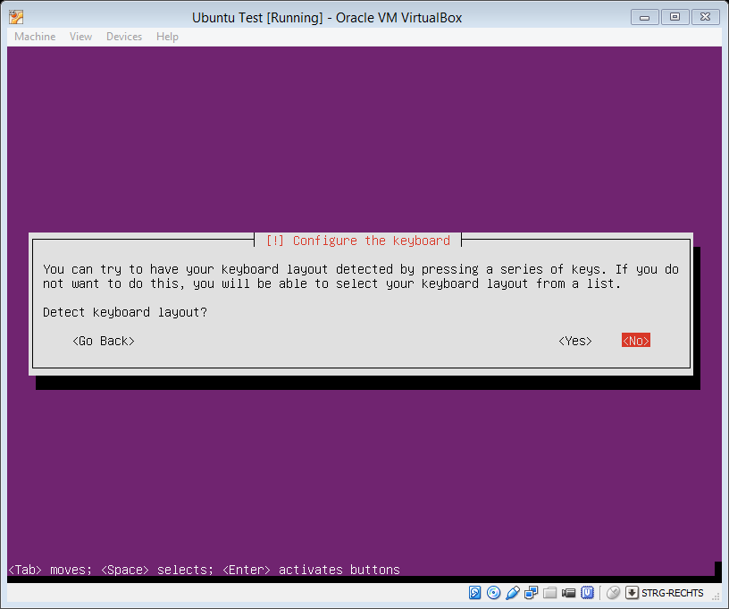

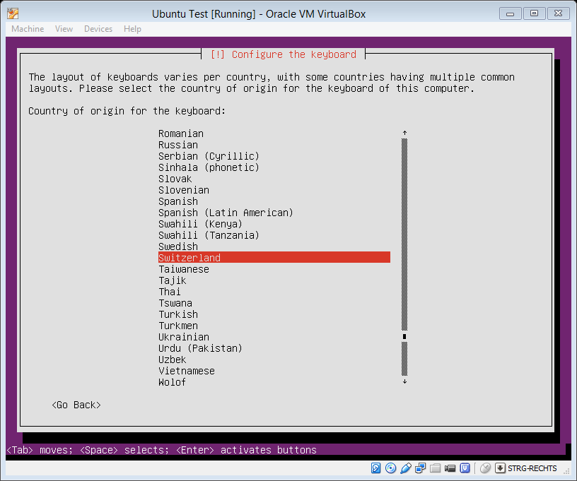

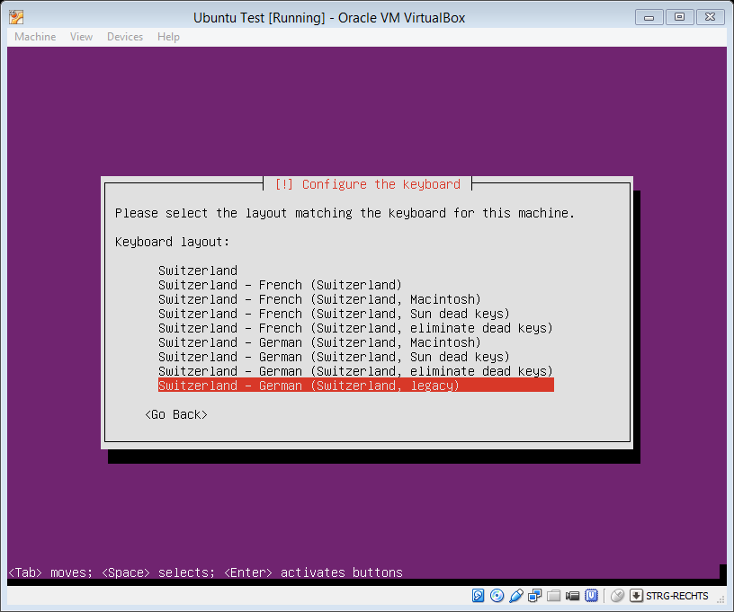

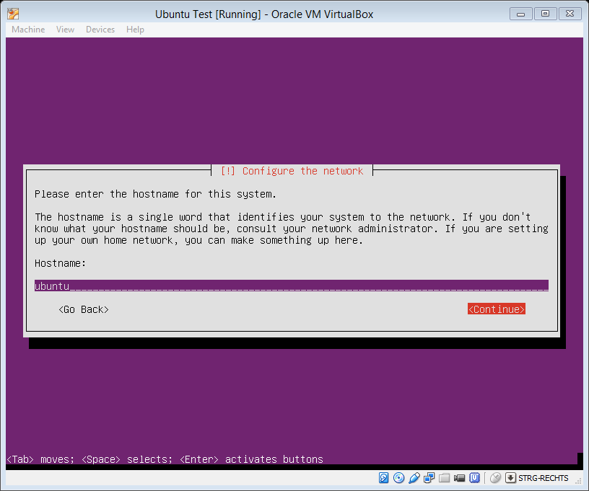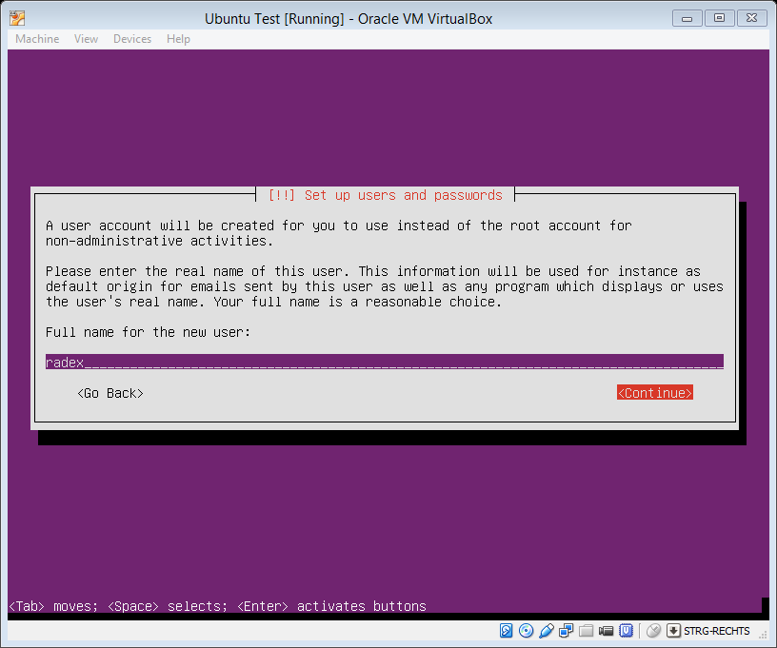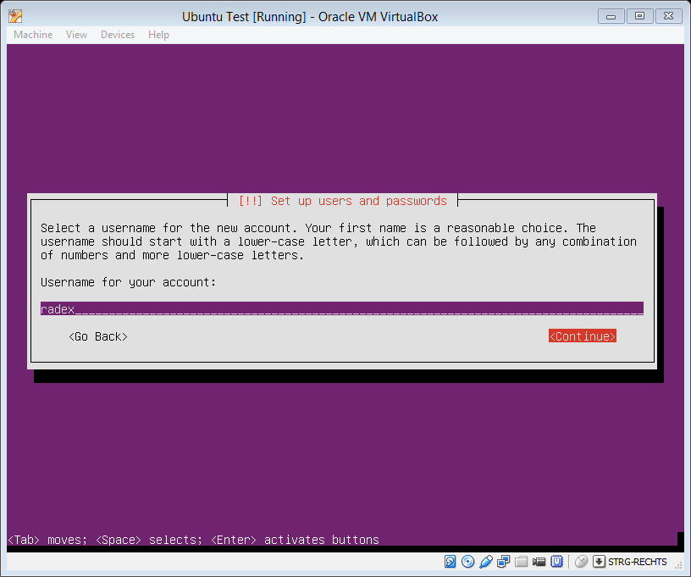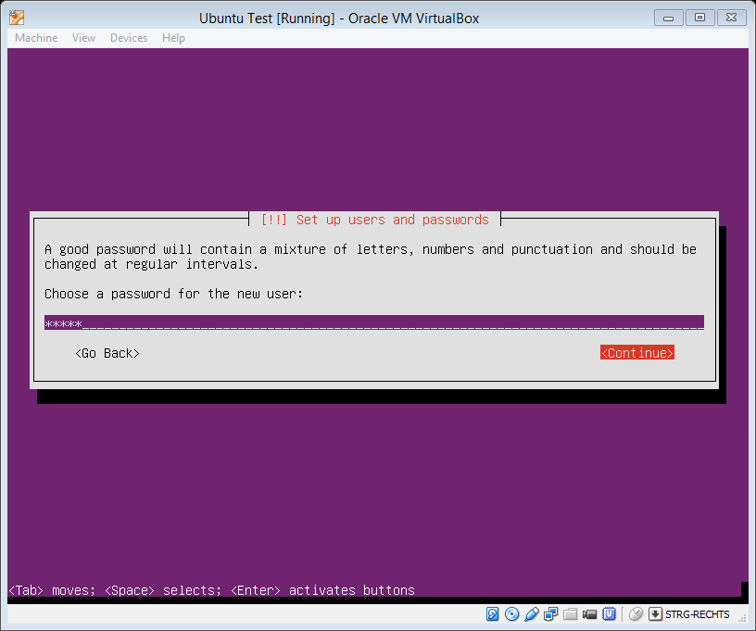Password “radex”

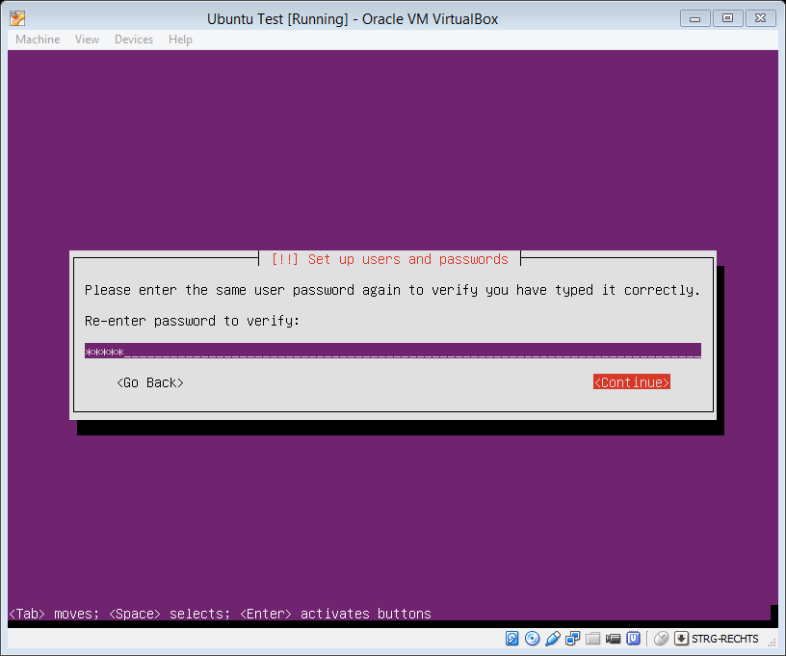

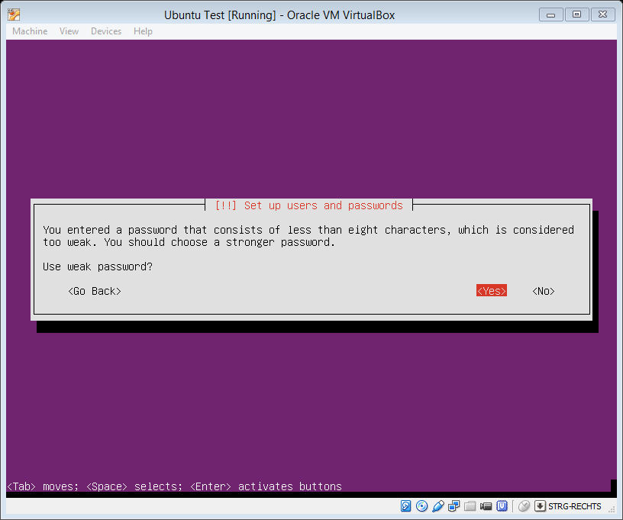

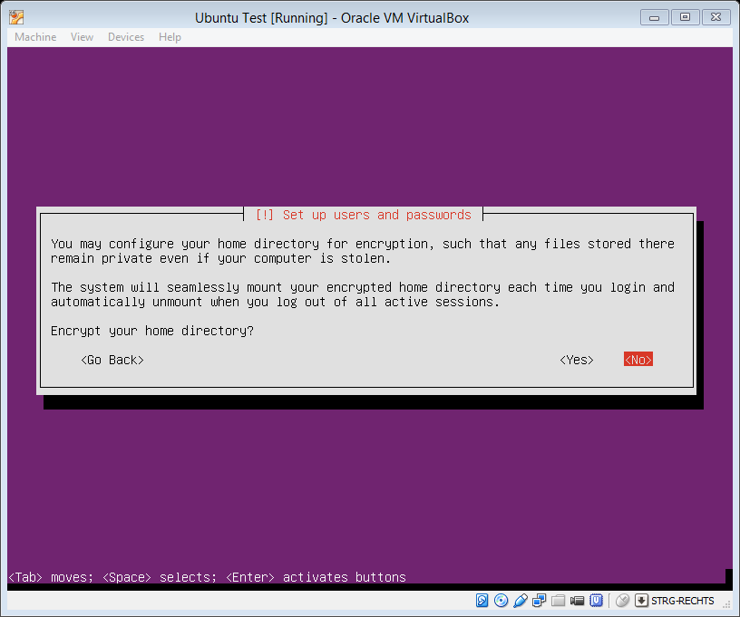

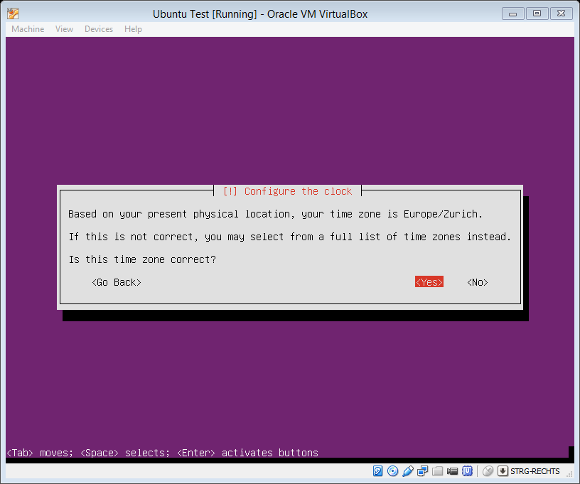

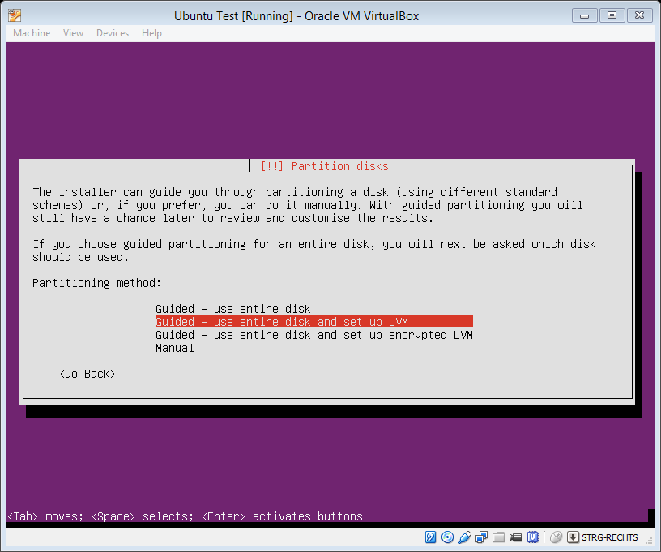

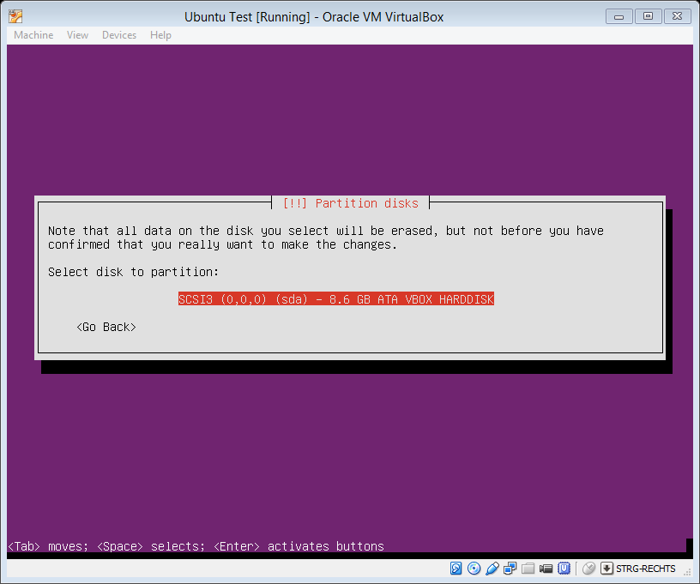

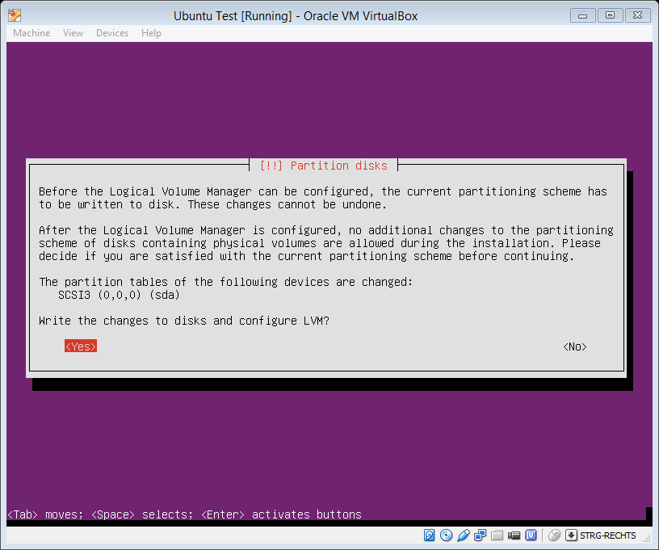

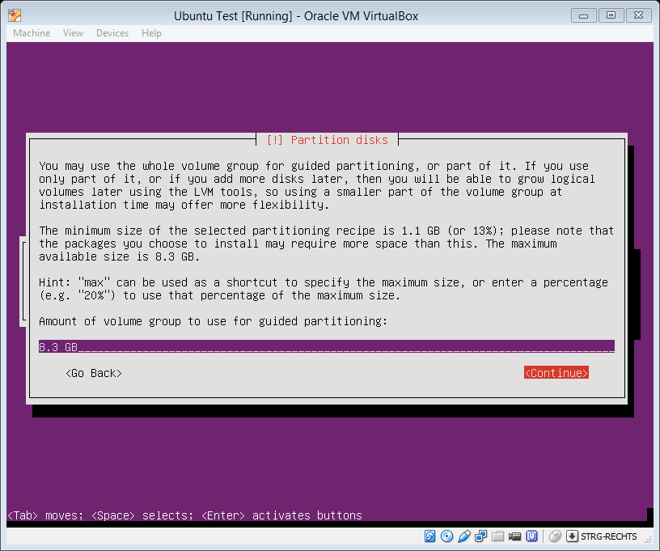

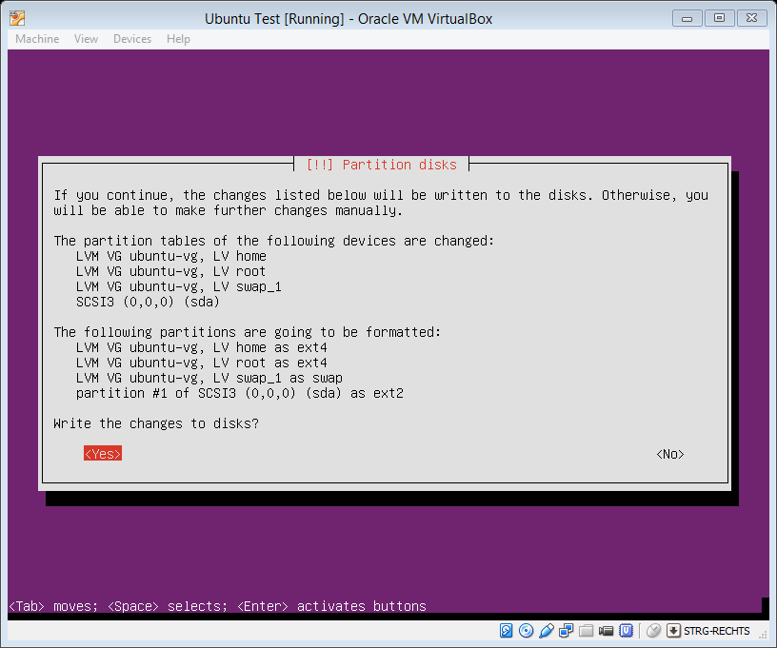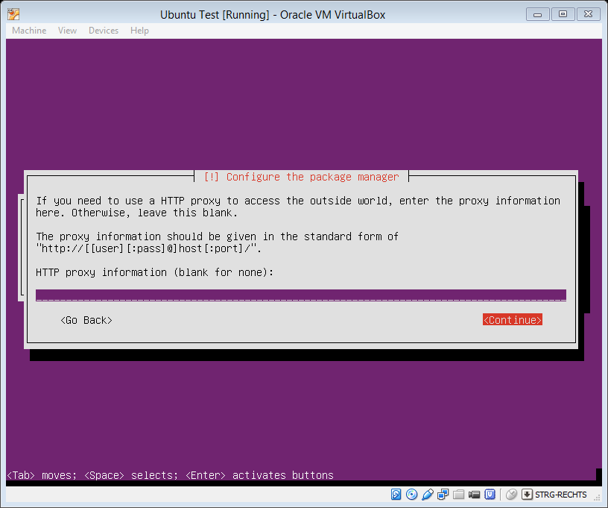

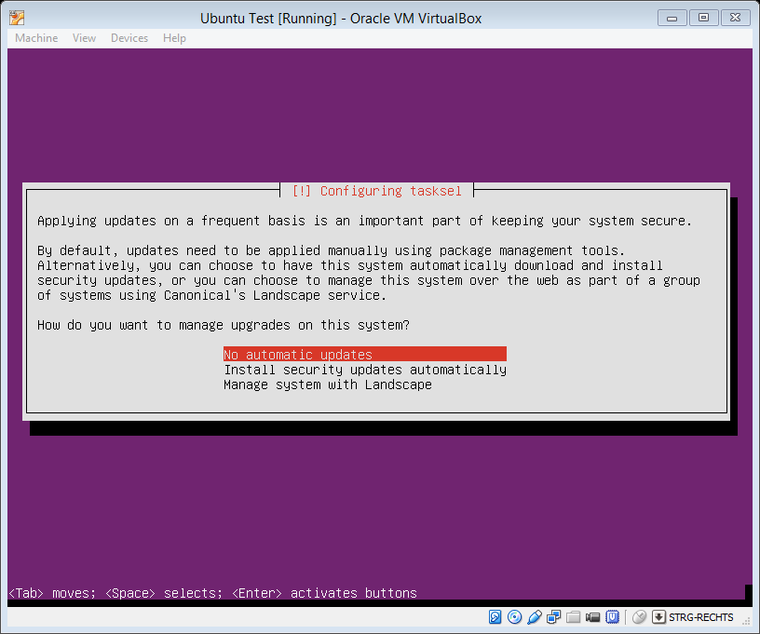

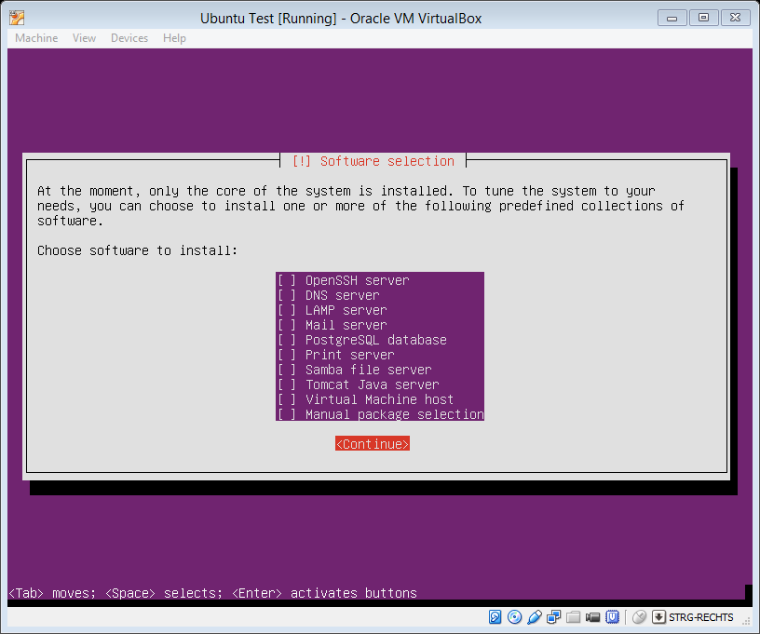

Select Options:

* OpenSSH server
* Samba file Server

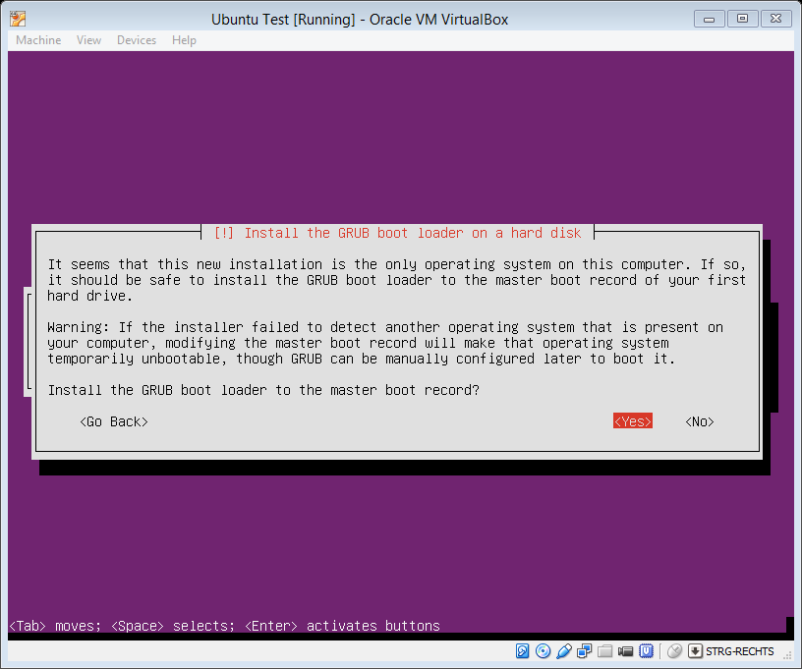

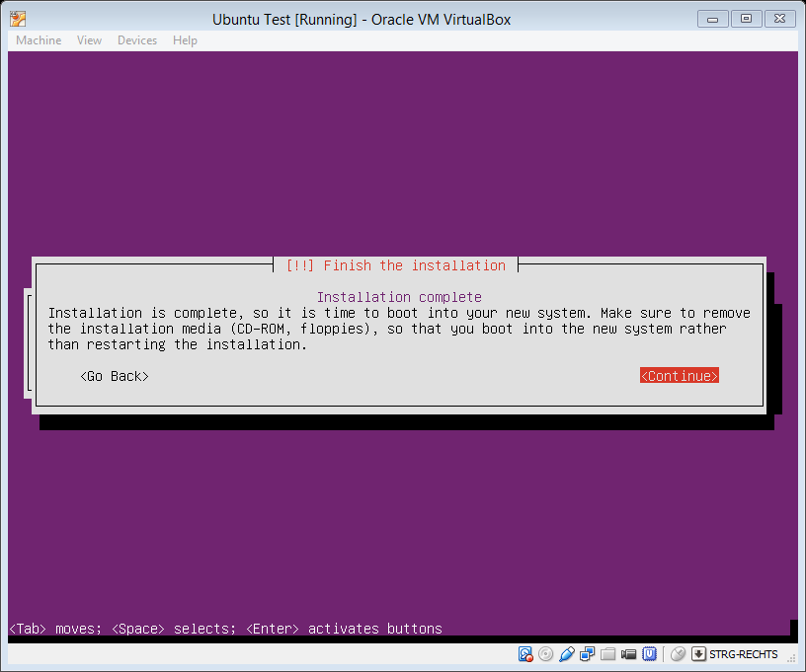

Additional libraries:

* sudo apt-get install gdbserver
* sudo apt-get install ipmitool (Tool to set IDENTIFY LED)
* ??? sudo apt-get install nfs-common (Tool needed for NetBoot)
* sudo -i
* sudo passwd root
  + Radex
* sudo mkdir /opt/radex
* sudo mkdir /opt/radex/bin
* sudo mkdir /opt/PrintData

Ab V14: Open SSH for root:

* sudo nano /etc/ssh/sshd_config
* *sucht nach der Zeile (STRG + W ist Suchen) nach*
* PermitRootLogin without‐password
* *und setzt ein # davor:*
* #PermitRootLogin without‐password
* *Speichert die Datei und startet den ssh Dienst neu:*
* sudo service ssh restart